Week 1 – Week 3: setting up the project topic

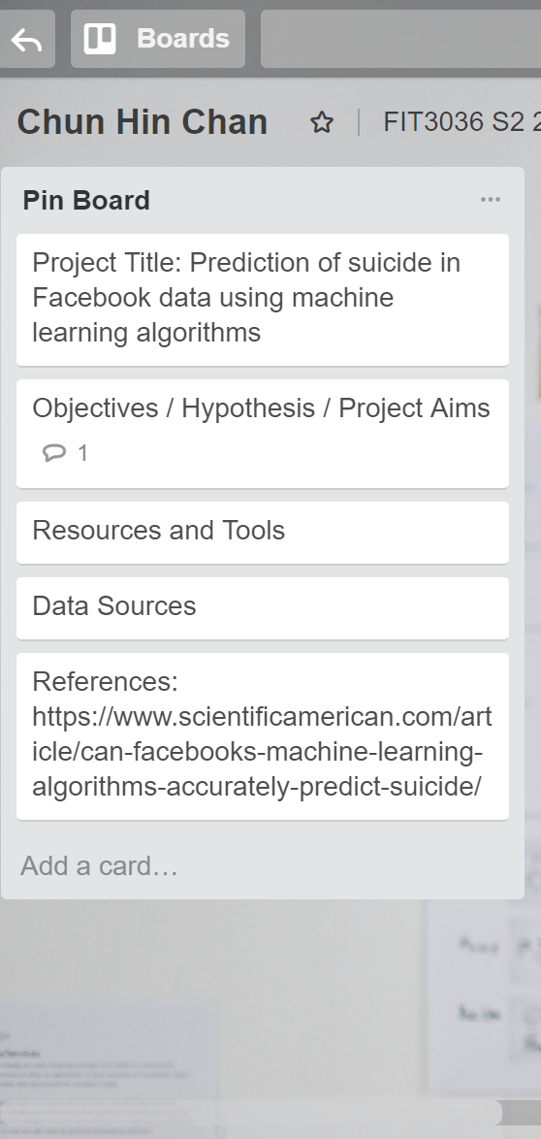

Week 4: Setting the three outcomes of the project

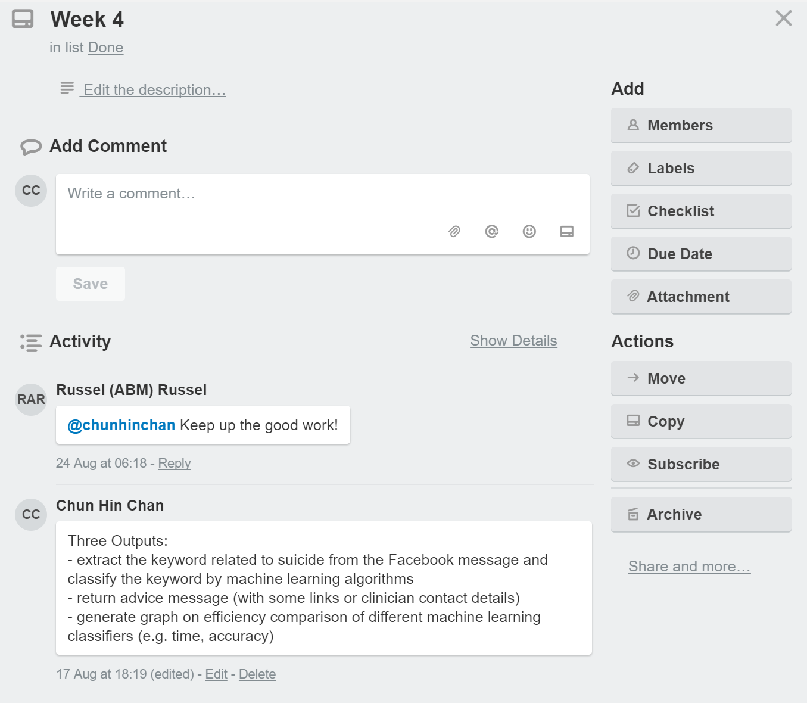

Week 5: Design the workflow and the system architecture

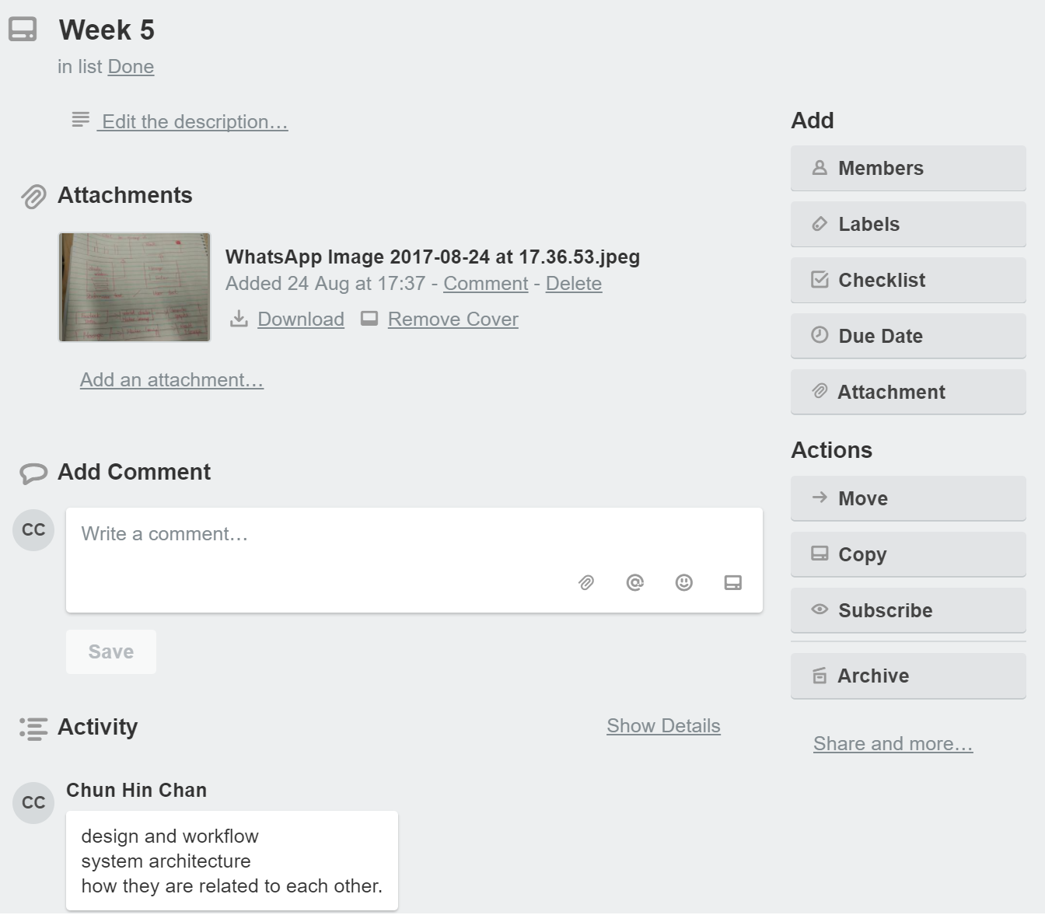

Week 6: working on the proposal

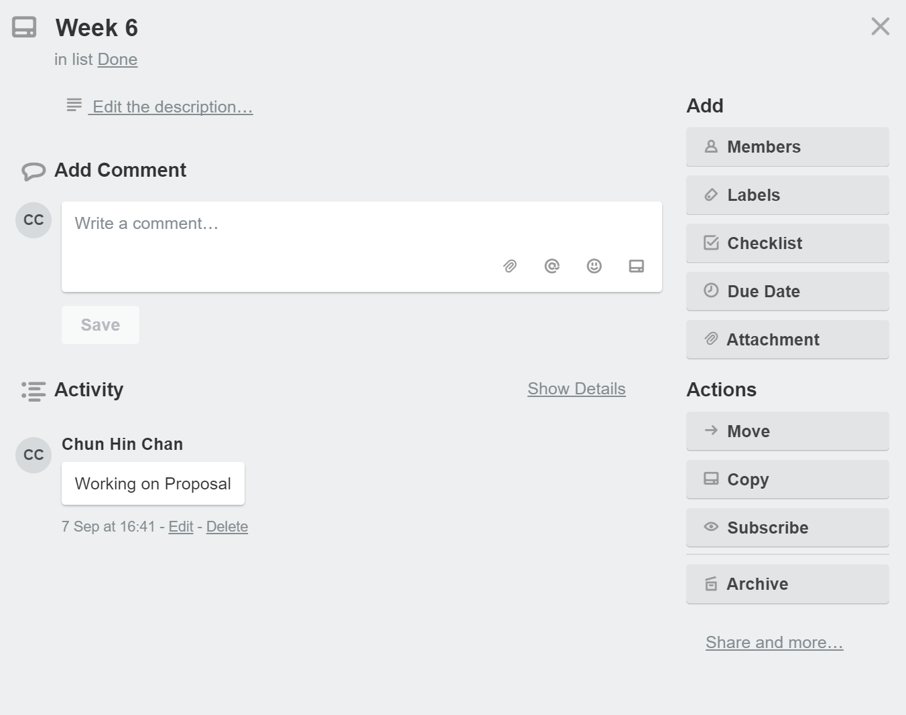

Week 7: Writing the Test plan for the project

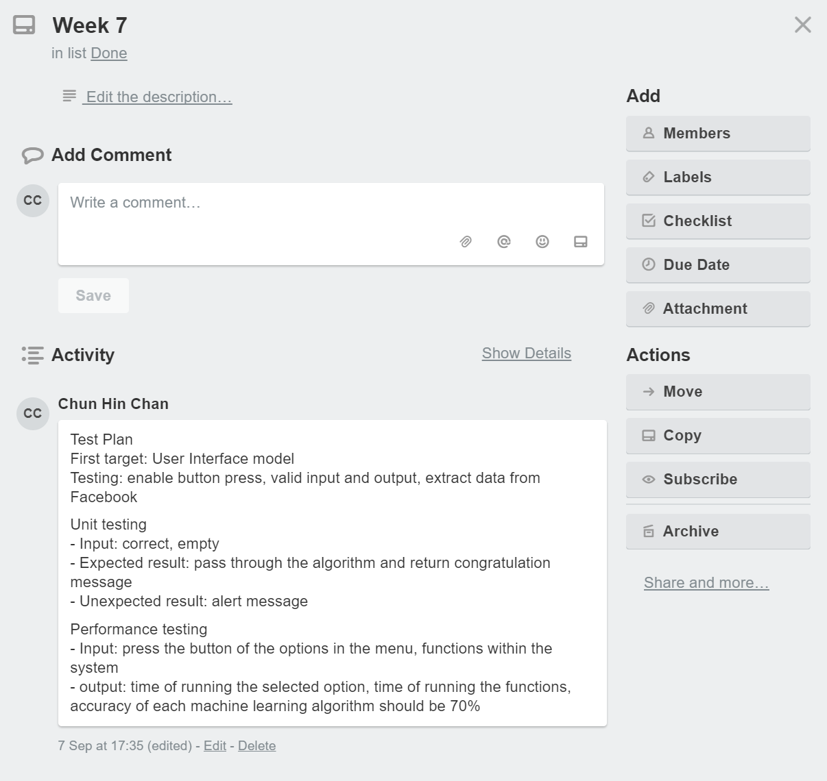

Week 8: The first demo of the project

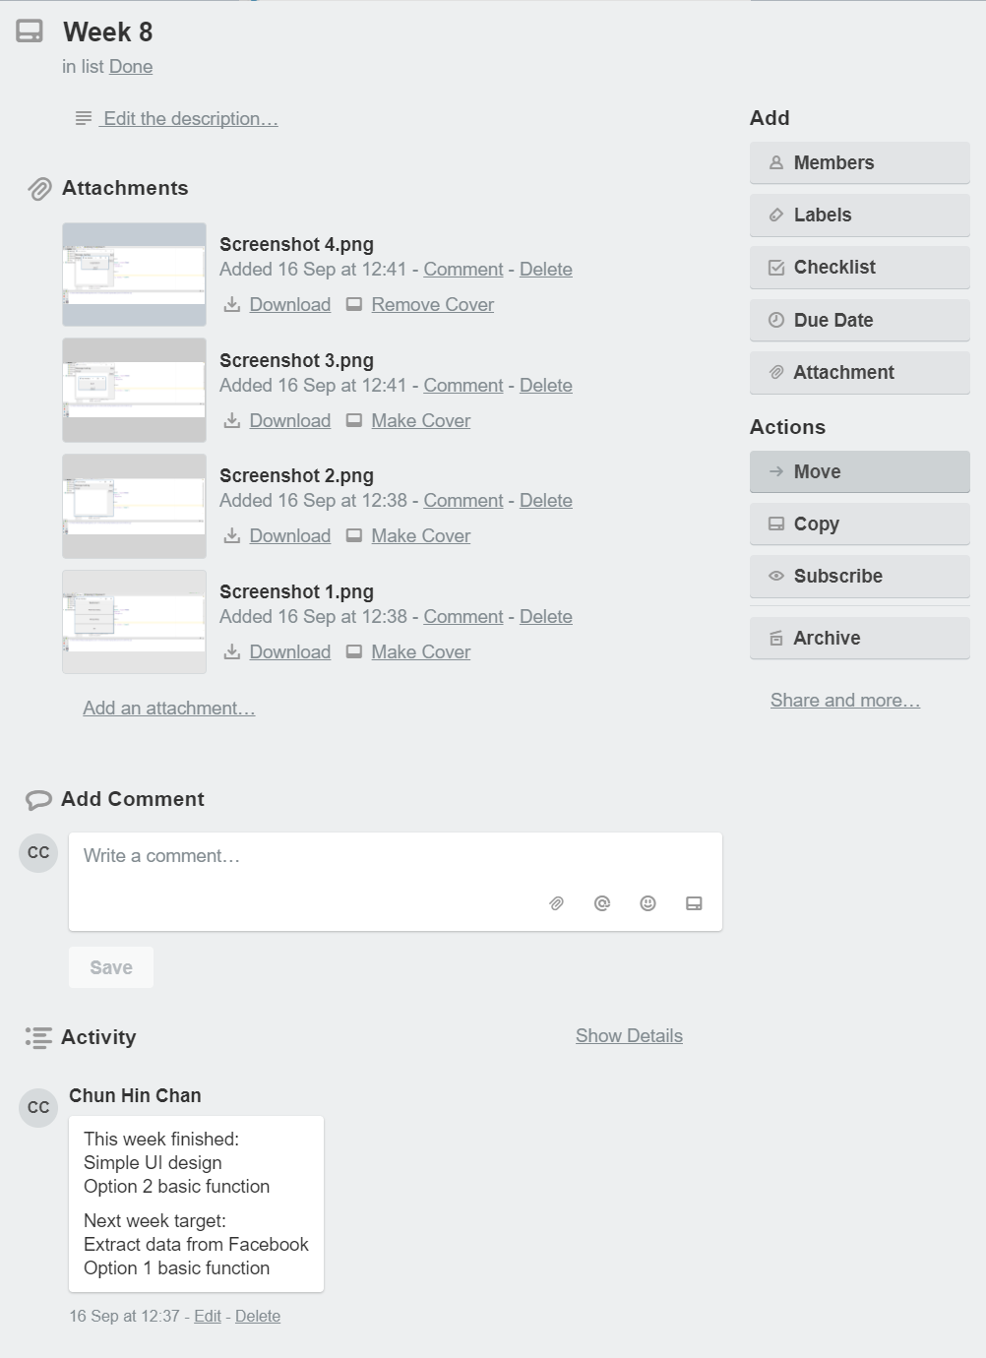

Week 9: The second demo of the project

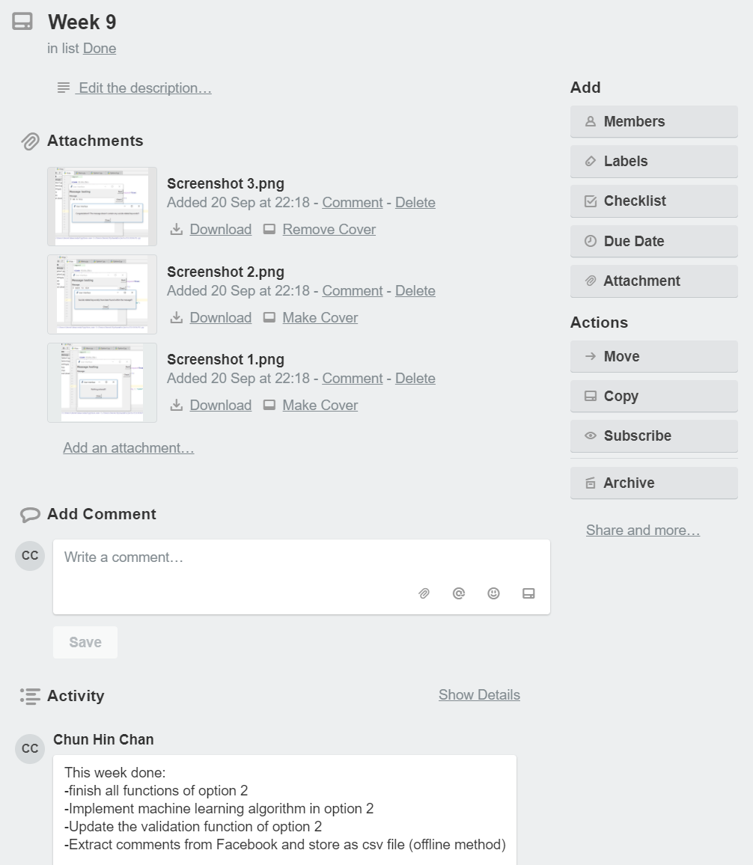

Week 10: The last demo of the project

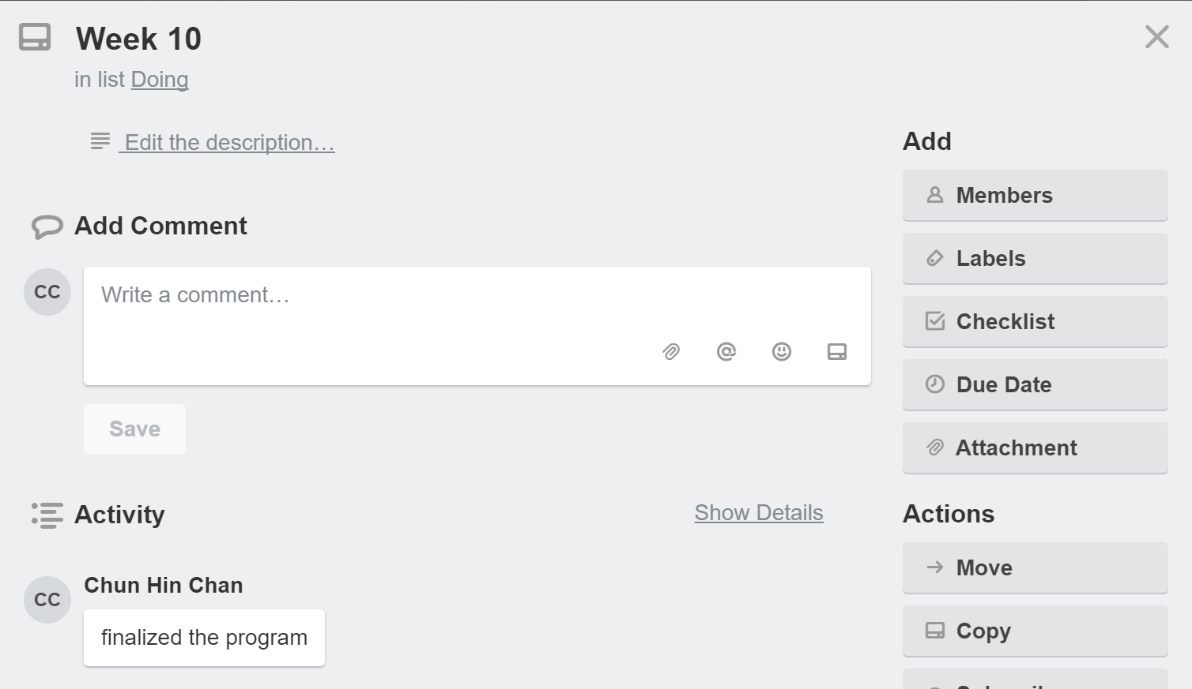

Week 11: The first week of presentation

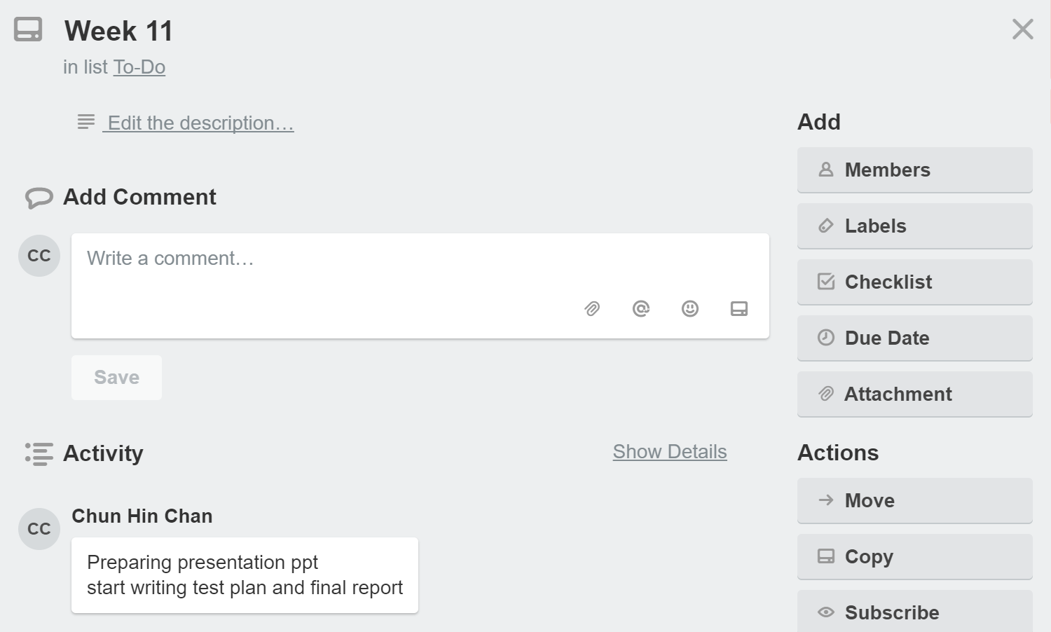

Week 12: Presentation and finishing the final report and test report

